| import cv2  import numpy as np  img_zeros = np.zeros((600,800,3), dtype=np.uint8)  height, width = img_zeros.shape[:2]  img_zeros[height//2:,:]=255 # 이미지의 height의 절반부터 255로 만듬  cv2.imshow('dst',img_zeros)  cv2.waitKey(0)  cv2.destroyAllWindows() |
| --- |

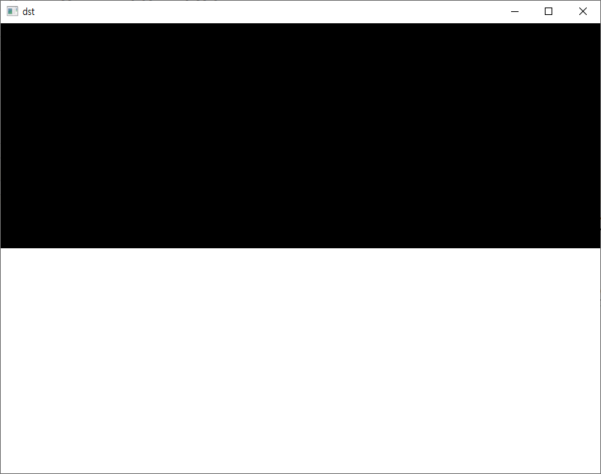

ArgMax함수 : 최대값의 좌표 리턴

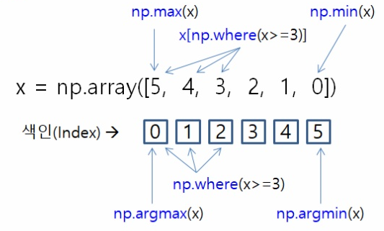

| import numpy as np  histogram = [0,1,2,3,4,5]  midpoint = len(histogram)//2  # midpoint = histogram.shape[0] // 2  # 1 2 3  leftx_base = np.argmax(histogram[:midpoint])  # 4 5 6  rightx_base = np.argmax(histogram[midpoint:])+midpoint  print(leftx_base,rightx_base) |
| --- |

| 2 5 |
| --- |

윈도우 그리기 # 1

| import cv2  import numpy as np  nwindows = 9  margin = 150  img_src = cv2.imread('images/warped_image.jpg',cv2.IMREAD_COLOR)  img_binary = cv2.cvtColor(img_src,cv2.COLOR_BGR2GRAY)  height, width = img_binary.shape[:2]  # 이미지의 아래쪽 절반의 column의 합(|||||)을 리스트로  histogram = np.sum(img_binary[height//2:,:], axis=0)  midpoint = len(histogram)//2  # histogram에서 좌우측의 최대값의 좌표를 구함  leftx_base = np.argmax(histogram[:midpoint])  rightx_base = np.argmax(histogram[midpoint:])+midpoint  # 여러개의 윈도우로 자를때 각 윈도우의 높이  window_height = int(height/nwindows)  leftx_current = leftx_base  rightx_current = rightx_base  for window in range(nwindows):  win_y_low = height - (window+1)*window_height  win_y_high = height - window*window_height  win_xleft_low = leftx_current - margin  win_xleft_high = leftx_current + margin  win_xright_low = rightx_current - margin  win_xright_high = rightx_current + margin  cv2.rectangle(img_src, (win_xleft_low,win_y_low),  (win_xleft_high,win_y_high),(100,255,255), 3)  cv2.rectangle(img_src, (win_xright_low, win_y_low),  (win_xright_high, win_y_high),(100,255,255), 3)  cv2.imshow('dst',img_src)  cv2.waitKey(0)  cv2.destroyAllWindows() |
| --- |

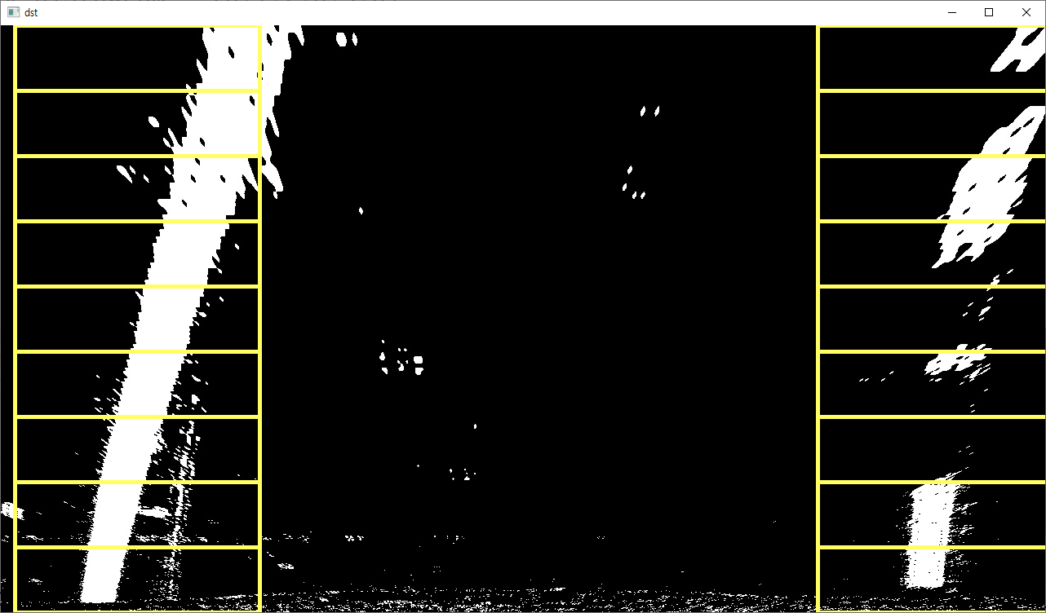

NON-Zero

| import numpy as np  # 이미지 가운데 0이아닌 값의 좌표값을 리턴함  img = np.array([[0,1,2],[3,4,0]])  nonzero = img.nonzero()  nonzero_y = np.array(nonzero[0])  nonzero_x = np.array(nonzero[1])  print(nonzero_y)  print(nonzero_x) |
| --- |

| [0 0 1 1]  [1 2 0 1] |  |
| --- | --- |

사각형 윈도우 업데이트

| import cv2  import numpy as np  nwindows = 9  margin = 150  minpix = 1  img_src = cv2.imread('images/warped_image.jpg',cv2.IMREAD_COLOR)  img_binary = cv2.cvtColor(img_src,cv2.COLOR_BGR2GRAY)  height, width = img_binary.shape[:2]  histogram = np.sum(img_binary[height//2:,:], axis=0)  midpoint = len(histogram)//2  leftx_base = np.argmax(histogram[:midpoint])  rightx_base = np.argmax(histogram[midpoint:])+midpoint  window_height = int(height/nwindows)  # 영상에서 0이 아닌 모든 점의 x,y점을 정의  nonzero = img_binary.nonzero()  nonzero_y = np.array(nonzero[0])  nonzero_x = np.array(nonzero[1])  leftx_current = leftx_base  rightx_current = rightx_base  #왼쪽, 오른쪽 차선의 조건을 만족하는 nonzero index를 받기 위해 리스트 생성  left_lane_inds = []  right_lane_inds = []  for window in range(nwindows):  win_y_low = height - (window+1)*window_height  win_y_high = height - window*window_height  win_xleft_low = leftx_current - margin  win_xleft_high = leftx_current + margin  win_xright_low = rightx_current - margin  win_xright_high = rightx_current + margin  cv2.rectangle(img_src, (win_xleft_low,win_y_low),  (win_xleft_high,win_y_high),(100,255,255), 3)  cv2.rectangle(img_src, (win_xright_low, win_y_low),  (win_xright_high, win_y_high),(100,255,255), 3)  # 아래 조건을 만족하는 점들의 인덱스 값을 리턴함  good_left_inds = ((nonzero_y >= win_y_low) &  (nonzero_y < win_y_high) &  (nonzero_x >= win_xleft_low) &  (nonzero_x < win_xleft_high)).nonzero()[0]  good_right_inds = ((nonzero_y >= win_y_low) &  (nonzero_y < win_y_high) &  (nonzero_x >= win_xright_low) &  (nonzero_x < win_xright_high)).nonzero()[0]  # 리스트에 조건을 만족하는 인덱스 값을 append  left_lane_inds.append(good_left_inds)  right_lane_inds.append(good_right_inds)  # If you found > minpix 픽셀의 개수가 minpix보다 크면 사각형의 센터값 업데이트  if len(good_left_inds) > minpix:  leftx_current = int(np.mean(nonzero_x[good_left_inds]))  if len(good_right_inds) > minpix:  rightx_current = int(np.mean(nonzero_x[good_right_inds]))  cv2.imshow('dst',img_src)  cv2.waitKey(0)  cv2.destroyAllWindows() |
| --- |

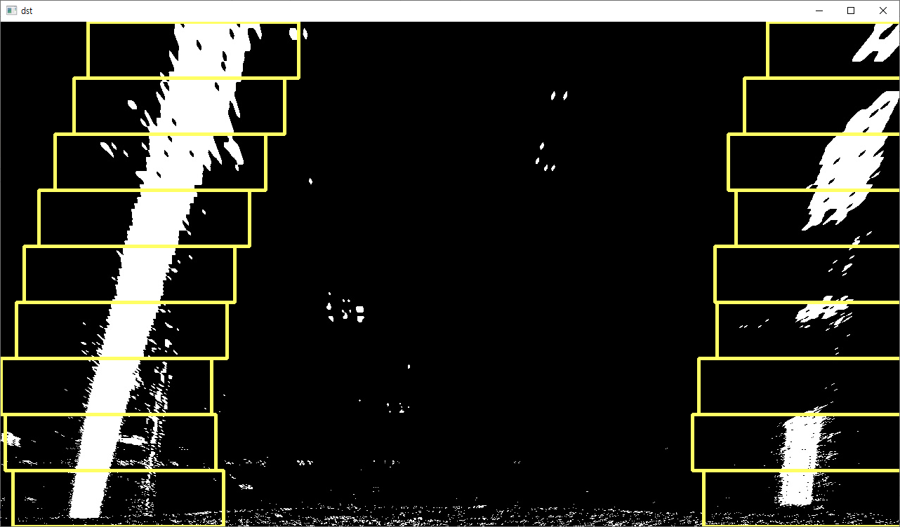

1차원 배열 합치기

| import numpy as np  arrays = [np.array([1,2,3]),np.array([5,6,7])]  # arrays = [[1,2,3], [5,6,7]]  print(arrays)  arrays = np.concatenate(arrays)  print(arrays) |
| --- |

| [array([1, 2, 3]), array([5, 6, 7])]  [1 2 3 5 6 7] |
| --- |

NonZero 추출하여 선그리기

| import cv2  import numpy as np  nwindows = 9  margin = 150  minpix = 1  left_a, left_b, left_c = [],[],[]  right_a, right_b, right_c = [],[],[]  img_src = cv2.imread('images/warped_image.jpg',cv2.IMREAD_COLOR)  img_binary = cv2.cvtColor(img_src,cv2.COLOR_BGR2GRAY)  height, width = img_binary.shape[:2]  left_fit_= np.empty(3)  right_fit_ = np.empty(3)  histogram = np.sum(img_binary[height//2:,:], axis=0)  midpoint = len(histogram)//2  leftx_base = np.argmax(histogram[:midpoint])  rightx_base = np.argmax(histogram[midpoint:])+midpoint  window_height = int(height/nwindows)  # 영상에서 0이 아닌 모든 점의 x,y점을 정의  nonzero = img_binary.nonzero()  nonzero_y = np.array(nonzero[0])  nonzero_x = np.array(nonzero[1])  leftx_current = leftx_base  rightx_current = rightx_base  #왼쪽, 오른쪽 차선의 조건을 만족하는 nonzero index를 받기위해 리스트 생성  left_lane_inds = []  right_lane_inds = []  for window in range(nwindows):  win_y_low = height - (window+1)*window_height  win_y_high = height - window*window_height  win_xleft_low = leftx_current - margin  win_xleft_high = leftx_current + margin  win_xright_low = rightx_current - margin  win_xright_high = rightx_current + margin  cv2.rectangle(img_src, (win_xleft_low,win_y_low),  (win_xleft_high,win_y_high),(100,255,255), 3)  cv2.rectangle(img_src, (win_xright_low, win_y_low),  (win_xright_high, win_y_high),(100,255,255), 3)  # 아래 조건을 만족하는 점들의 인덱스 값을 리턴함  good_left_inds = ((nonzero_y >= win_y_low) &  (nonzero_y < win_y_high) &  (nonzero_x >= win_xleft_low) &  (nonzero_x < win_xleft_high)).nonzero()[0]  good_right_inds = ((nonzero_y >= win_y_low) &  (nonzero_y < win_y_high) &  (nonzero_x >= win_xright_low) &  (nonzero_x < win_xright_high)).nonzero()[0]  # 리스트에 조건을 만족하는 인덱스 값을 append  left_lane_inds.append(good_left_inds)  right_lane_inds.append(good_right_inds)  # If you found > minpix 픽셀의 개수가 minpix보다 크면 사각형의 센터값 업데이트  if len(good_left_inds) > minpix:  leftx_current = int(np.mean(nonzero_x[good_left_inds]))  if len(good_right_inds) > minpix:  rightx_current = int(np.mean(nonzero_x[good_right_inds]))  # Concatenate the arrays of indices  left_lane_inds = np.concatenate(left_lane_inds)  right_lane_inds = np.concatenate(right_lane_inds)  # Extract left and right line pixel positions  leftx = nonzero_x[left_lane_inds]  lefty = nonzero_y[left_lane_inds]  rightx = nonzero_x[right_lane_inds]  righty = nonzero_y[right_lane_inds]  # Fit a second order polynomial to each  left_fit = np.polyfit(lefty, leftx, 2)  right_fit = np.polyfit(righty, rightx, 2)  left_a.append(left_fit[0])  left_b.append(left_fit[1])  left_c.append(left_fit[2])  right_a.append(right_fit[0])  right_b.append(right_fit[1])  right_c.append(right_fit[2])  left_fit_[0] = np.mean(left_a[-10:])  left_fit_[1] = np.mean(left_b[-10:])  left_fit_[2] = np.mean(left_c[-10:])  right_fit_[0] = np.mean(right_a[-10:])  right_fit_[1] = np.mean(right_b[-10:])  right_fit_[2] = np.mean(right_c[-10:])  # x 와 y 값을 그리기 위해 생성  # 0부터 height-1(99)까지 height(100)개 만큼 1차원 배열 만들기  ploty = np.linspace(0, height-1, height)  left_fitx = left_fit_[0] * ploty ** 2 + left_fit_[1] * ploty + left_fit_[2]  right_fitx = right_fit_[0] * ploty ** 2 + right_fit_[1] * ploty + right_fit_[2]  img_src[nonzero_y[left_lane_inds], nonzero_x[left_lane_inds]] = [255, 0, 100]  img_src[nonzero_y[right_lane_inds], nonzero_x[right_lane_inds]] = [0, 100, 255]  ########################################  # 아래코드 추가 하기 : 여기  ########################################  cv2.imshow('dst',img_src)  cv2.waitKey(0)  cv2.destroyAllWindows() |
| --- |

위의 코드에 합치기

| color_img = np.zeros_like(img_src)  left = np.array([np.transpose(np.vstack([left_fitx, ploty]))])  right = np.array([np.flipud(np.transpose(np.vstack([right_fitx, ploty])))])  points = np.hstack((left, right))  # 차선 그리기  cv2.polylines(color_img, np.int_(points), False, (0, 255, 255),10)  # 차선 안쪽 채우기  #cv2.fillPoly(color_img, np.int_(points), (0, 255, 0))  # 원본영상과 차선검출 영상 합치기 : 가중치 조절(1:100%, 0.4:40%)  img_src = cv2.addWeighted(img_src, 1, color_img, 0.4, 0) |
| --- |

예제

| import numpy as np  left_fitx = [2,3,4]  right_fitx = [22,23,24]  ploty = [10,11,12]  print(np.vstack([left_fitx, ploty]))  left = np.array([np.transpose(np.vstack([left_fitx, ploty]))])  print(left)  print(np.vstack([right_fitx, ploty]))  right = np.array([np.flipud(np.transpose(np.vstack([right_fitx, ploty])))])  print(right)  points = np.hstack((left, right))  print(points) |
| --- |

|  | | |
| --- | --- | --- |
| np.vstack([left_fitx, ploty]) | np.array([np.transpose(np.vstack([left_fitx, ploty]))]) | |

|  | | |
| --- | --- | --- |
| np.vstack([right_fitx, ploty]) | np.array([np.flipud(np.transpose(np.vstack([right_fitx, ploty])))]) | |

|  |
| --- |